**Key Features**

* ***Unit & Integration Testing***  - TIBUnit provides ability to write Unit Tests having test assertions, integration test cases that need to invoke services and components across various platforms.
* ***Multi step tests*** - Multiple assertions can be used in one test case.
* ***Developer IDE -*** TIBCO Designer can be used as IDE
* ***Assertion -***  support is wide variety of assert functions for logical operation and Exceptions checks.
* ***BW Pallet support*** provides flexibility to use any feature or pallet supported by BW for testcase writing.
* ***CLI Execution*** -Full test suite can be executed from Command Line and from within TIBCO Designer.
* ***CI Integration*** – Support integration with Build Servers like Jenkins.
* ***Test Result –*** generates XML and HTML based reports, maintainshistory of Test Run results. These results can be accessed via a web URL, and via a file sharing as XML.
* ***Test Input Data Parameterization*** Multiple Input Data set and expected Outcomes can be defined for one TIBUnit Test case.
* ***Protocol Support -*** TIBUnit can use be for all protocols supported by BW.
* ***Reusable and distributable -*** TIBUnit is distributed as BW library which can be shared and imported easily.

TIBUnit – TIBCO Unit and Integration Testing Framework

**An Overview**

TIBUnit is a TIBCO Unit and integration testing Tool written as BusinessWorks processes. Business Works process approach helps in shortens learning curve for Developers . With TIBUnit supporting TDD Approach , we can test every process your BW Project and it can be used not only for writing unit test cases for protocol like JMS, HTTP and JDBC as BusinessWorks , but also provides ability to write integration test cases that need to invoke services and components across various platforms. It supports multiple assertions with in single test case.

It comes with predefined asserts including assertions for Exception handling, test reports , Test report history

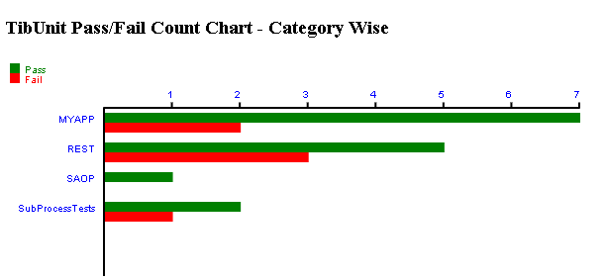

**Test Execution**

TIBUnit supports Command Line and full test suite from within TIBCO Designer.

**Integration**

***TIBCO Designer*** - TIBUnit is developed as Business works ,so this can be accessed from TIBCO Designer which make developers life easy

***CI Tools*** -it can be easily integrated with CI environment which helps in reducing the B&R time and ensures reliable repeatable builds that can be deployed across multiple environments.

**Flexible and Configurable**

TIBUnit provides flexibility to changes configurations settings for different environments. Also it allows us to setup multiple test inputs for testcases and ability to control test case execution.

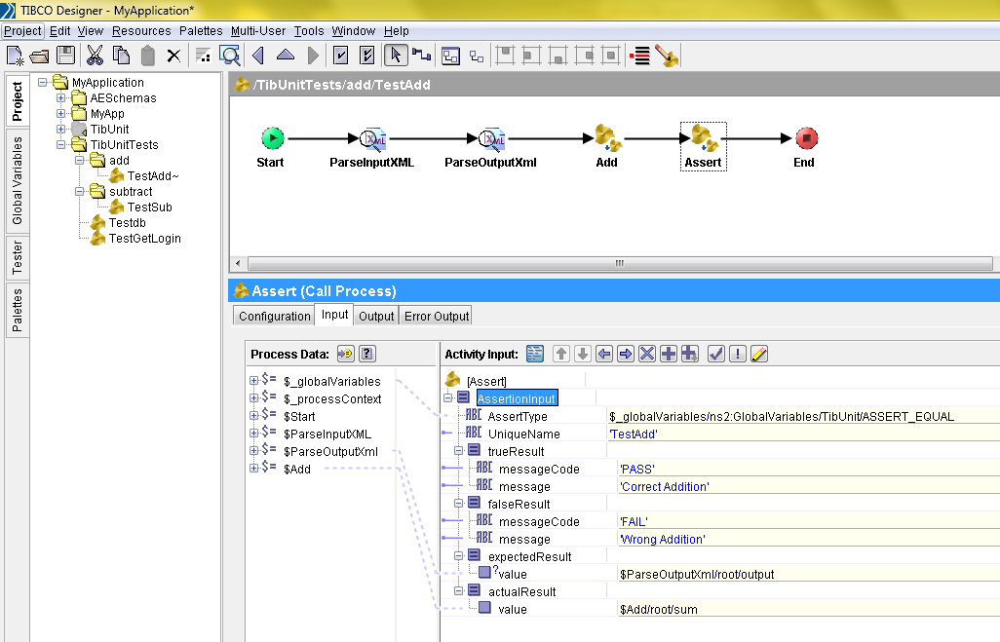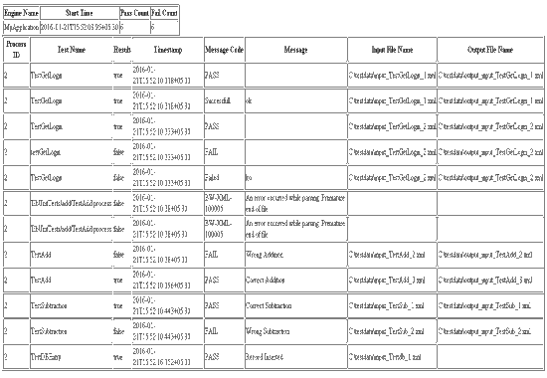

**Contact:**

Rahul Kumar Gupta (DoT)

(rgupta89@sapient.com)

Akhil Gupta (agupta29@sapient.com)

Sapient Nitro

Oxygen Boulevard , NOIDA